October 4, 2021
Ref: IIH/MD/2021/10/011
The Executive Chairman,
Kwara State Geographic Information Service,
Commissioner Lodge Way,
GRA, Ilorin, Kwara State.
Dear Sir,
REQUEST FOR VISIT TO SITE FOR 100MW SOLAR POWER PLANT
I was nominated by our Governor His Excellency AbdulRahman AbdulRazaq to be on the Northern States Governors Forum Technical Committee on the provision of 2000MW of solar energy to each of the ninetieen (19) northern states and the FCT in Nigeria, which equates to 100MW in each location. This committee was inaugurated by the Governor of Kaduna State, Mallam Bello Nasir El-Rufai, as the Chairman of the committee and he has written officially to request for provision of the land required for the project. I want to thank you for the speedy identification of this land and response.
Furthermore, I would like to request an official visit to the proposed site for the plant at a time of your convenience. Please let me know what date and time will work for this.
Thank you.
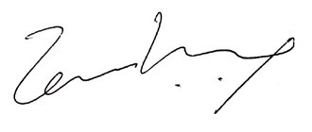

Temi Kolawole
ag. MD Ilorin Innovation Hub

